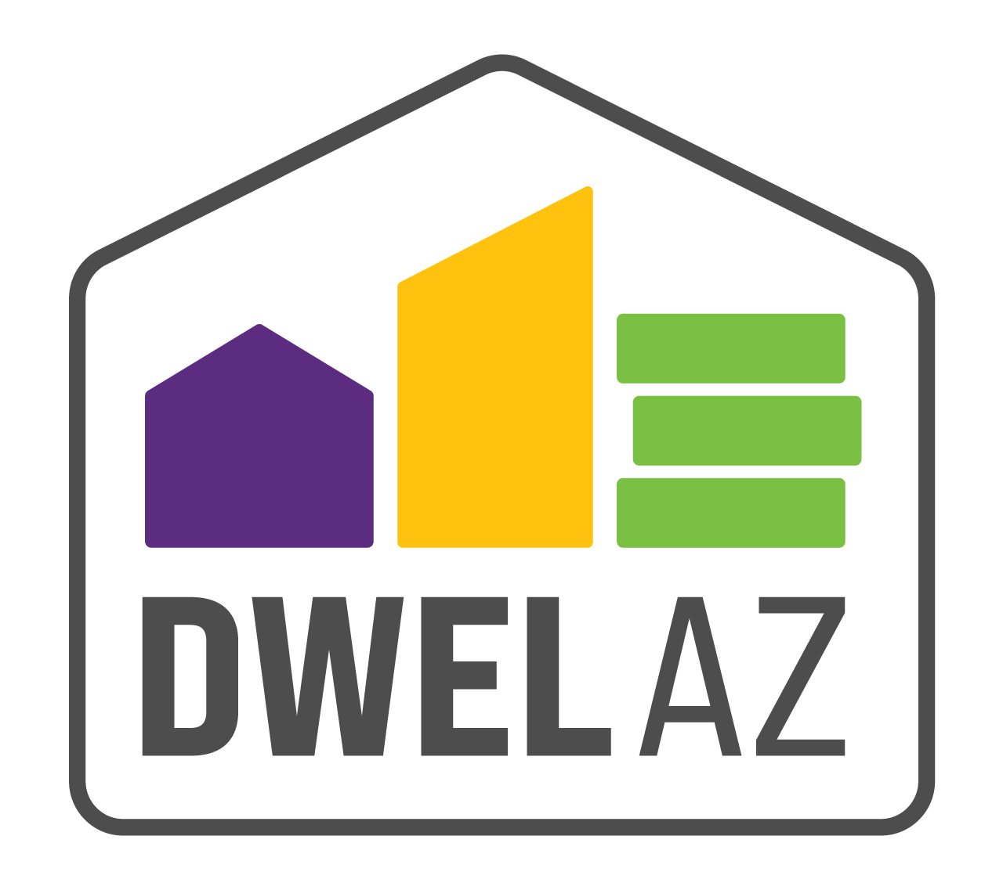

DWEL ROI Training

Learn more about the DWEL-AZ Statewide integrated data warehouse and be a part of a new initiative to improve care coordination across the State!

Please use the link below to sign up for a training date.

please forward to agency leadership and anyone using hmis serving the unhoused population.

[DWEL-ROI Training sign-up](https://forms.office.com/r/ciP1k1KG6c)

The goal of the DWEL-AZ ROI Training is to work with each community agency serving unhoused and vulnerable populations to develop a consistent agency-wide and statewide process for collecting the DWEL ROI for every individual entered into HMIS.

The purpose and function of the DWEL ROI is to collect and match AHCCCS Medicaid health information with an individual's HMIS profile. The health information includes AHCCCS demographic, program eligibility, and health information.

Integrating health and HMIS data will enable community agency staff to access verified information, more efficiently connect individuals to a broader range of housing options, minimize the administrative burden of collecting data from multiple sources, and lessen the number of times individuals must repeat their information to providers across the health and housing sectors.

I’m excited to see you there!

-Adria Tena, Program Administrator (Solari.Inc.)